Phonetics course part two : Practicing after theory.

We are going to practice distinguishing between some of the more tricky sounds of the I.P.A :

Instructions:

- I will read the two compared sounds after which you will imitate me.
- I will then read the short word list beneath the image so that you will be able to hear the differences.
- After that - it is your turn to read the word lists.

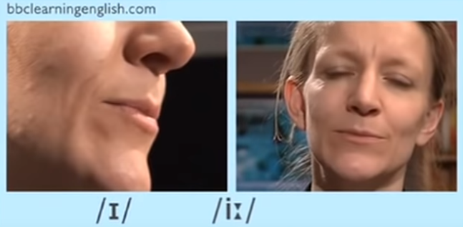

Let’s practice :

Hit =/hɪt/ - / heat = /hiːt/
Lip = /lɪp/ - leap =/liːp/
Sick = /sɪk/ - seek = /siːk/
Will = /wɪl/ - wheel = /wiːl/

Now try reading this:

Please hit the heat switch.
I painted my lips and then took a leap over.
When I feel sick, I seek a doctor’s advice.
Will you wheel the chair over to me ?

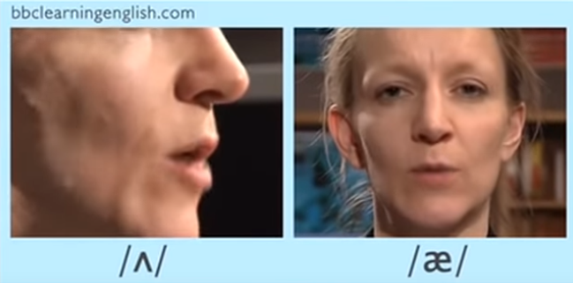

Let’s practice:

Uncle = /ˈʌŋk(ə)l/ - ankle = /ˈaŋk(ə)l/
Bunk = /bʌŋk/ - bank = /baŋk/
But = /bʌt,bət/ - bat = /bat/
Cup = /kʌp/ - cap = /kap/
Swum = /swʌm/ - swam = /swam/

Now try reading this :

My uncle broke his ankle jumping off a bunk at the bank but never lost his cap.
Have you ever swum in the ocean ? Yes, I swam there yesterday.

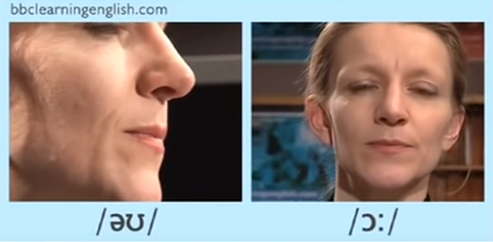

The diphthong ‘’Oh’’ - as seen above, can be tricky to distinguish from the vowel sound ‘aw’’

Let’s practice :

Coat = /kəʊt/ - Caught = /kɔːt/
Dough = /dəʊ/ - Door = /dɔː/
Sew = /səʊ/ - Saw =/sɔː/
Flow = /fləʊ/ - Floor = /flɔː/

Now try reading this :

If she had put on a coat, she would not have caught a cold.
He threw the dough and it stuck to the door.
I saw that she could not sew and so I helped her try to sew.
The water he held began to flow onto the floor. A steady flow on the floor by the door.

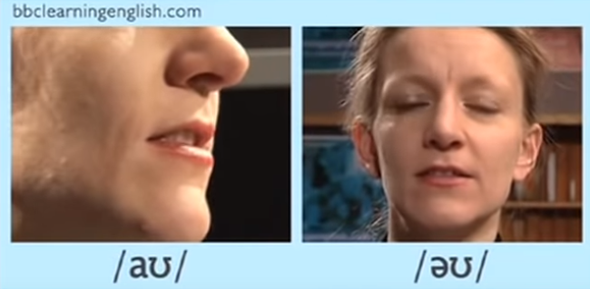

The diphthong ‘’ow’’ - as seen above, can be tricky to distinguish from the vowel sound ‘’eh’w’’

Let’s practice :

Couch = /kaʊtʃ/ - Coach = /kəʊtʃ/
Clown = /klaʊn/ - Clone = /kləʊn/
Loud = /laʊd/ - Load = /ləʊd/
Found = /faʊnd/ - Phoned = /fəʊnd/ ( Ph here - is known as a digraph - this is when two letters come together to form an entirely new sound in English. In this instance it is pronounced = F. )

Now try reading this:
The coach had no couches, only benches.
The clown was cloned and made to be loud and able to carry a heavy load.
I found he had phoned several times.

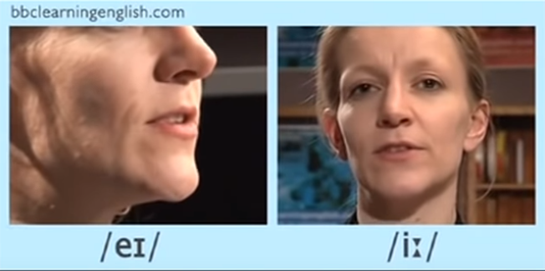

The diphthong ‘’ay’’ - as seen above, can be tricky to distinguish from the vowel sound ‘’ee’’

Let’s practice :

Ate = /ɛt,eɪt/ - Eat = /iːt/
Faced = /feɪst/ - Feast = /fiːst/
Great = /ɡreɪt/ - Greet = /ɡriːt/
Mate = /meɪt/ - Meet = /miːt/

Now try reading this :

I ate a great amount of eats at the feast, faced with so much!
It was great to greet my neighbour this morning.
Mate, when can we meet for coffee?

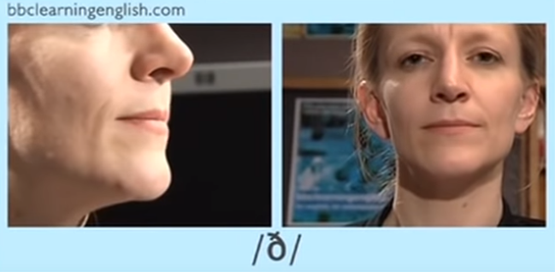

This is a voiced consonant, it is pronounced : thhh - when you pronounce it, your tongue should stick out just a little. The sound comes from between the tongue and top teeth ! You can hear this sound at the start of words such as : Then, This, There and That - in the middle of the word ‘Other’ and at the end of the word ‘smooth’.

Now you try :
Then
This
There
That
Other
Smooth
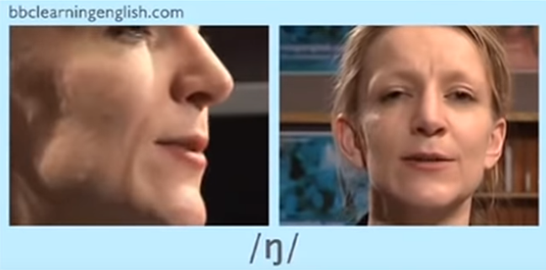
This is a consonant sound that comes at the end of a syllable. You will find it in the middle of the word ‘anger’ , the middle of the word ‘thanks’ and at the end of the word ‘rung’. We make this sound towards the back and top /roof of the mouth ! If you do it correctly - you will feel a vibration in your nose / at the top of your nose ! Try it.

Let’s practice:

Rung =/rʌŋ/
Anger = /ˈaŋɡə/
Thanks = /θaŋks/

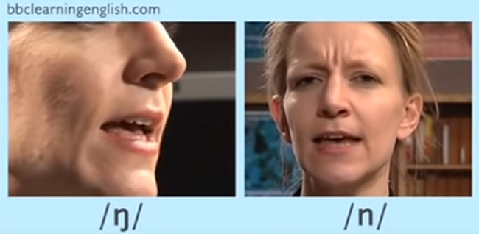

It is tricky trying to hear the differences between ‘’ng’’ and ‘’nuh’’.

Rung = /rʌŋ/ / Run = /rʌn/
Notice : ‘’ng’’ is made at the back of the mouth - towards the roof and ‘’nuh’’ is made just behind the front, top teeth.

Let’s practice :

Tongue = /tʌŋ/ - Ton = /tʌn/
Wing = /wɪŋ/ - Win = /wɪn/
Robbing = /rɒbŋ/ - Robin = /ˈrɒbɪn/
Singer = /ˈsɪŋə/ - Sinner = /ˈsɪnə/

Now try reading this:

I pierced my tongue, it cost a ton of money.
You will never win with a broken wing.
Robin Hood was out robbing the rich.
My friend is a singer who sings about sinners.

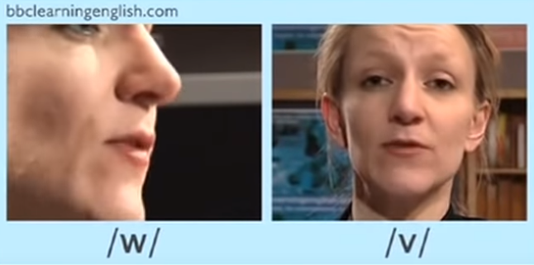

These two sounds can be rather tricky for certain speakers of English.

The w sound is made by bringing your lips together and outwards as if blowing a kiss or pretending to be a goldfish. You should feel air move out between your lips - try it : W - Wet - W - Worry.

To form the V sound - bite down slightly, on your bottom lip - your lips should not be pursed ( rounded like a goldfish.) but stretched slightly - top teeth coming down on your bottom lip like a vampire.

Let’s practice:

Wet = /wɛt/ - Vet = /vɛt/
Worse = /wəːs/ - Verse = /vəːs/
While = /wʌɪl/ - Vile = /vʌɪl/
West = /wɛst/ - Vest = /vɛst/
Wary = /ˈwɛːri/ - Vary = /ˈvɛːri/

Now try reading this:

I was very tired after I had woven a woolen vest for my neighbour.

When will Verity arrive? It is Wednesday and I am very worried.

The schwa sound is usually in unstressed syllables : The most frequent sound in English :

Let’s practice with a few words of one syllable :

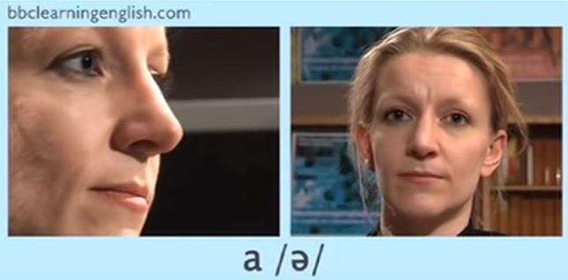

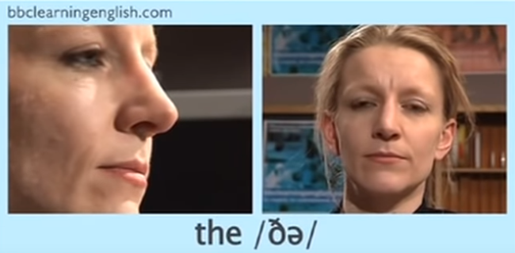

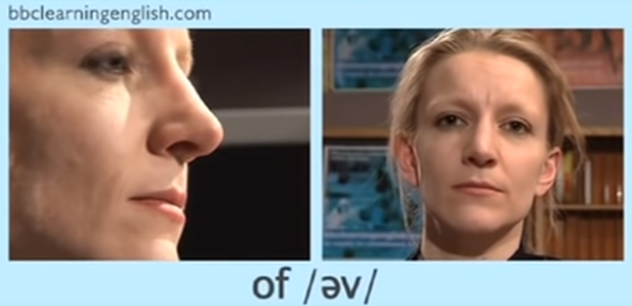

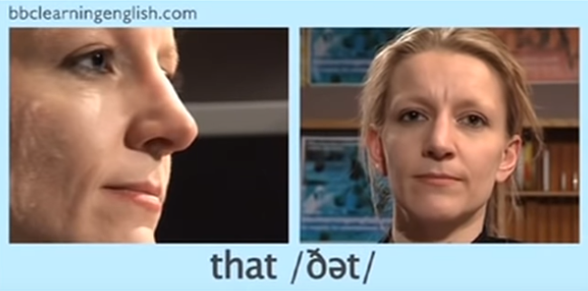

The schwa sound also occurs in words of more than one syllable :

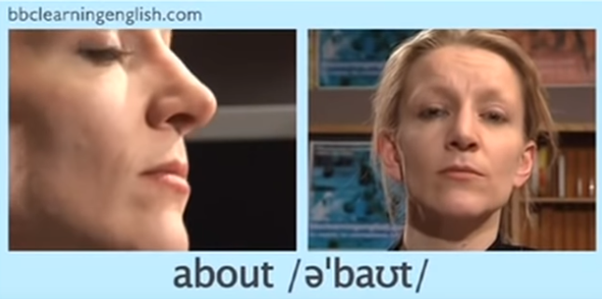

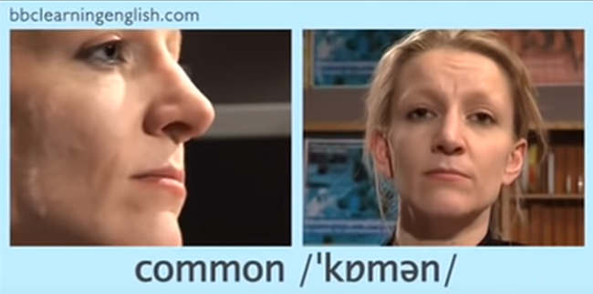

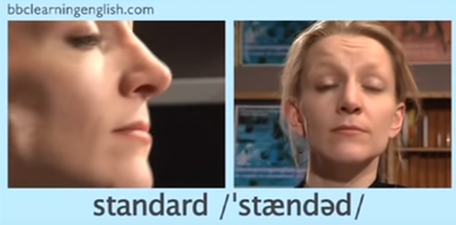
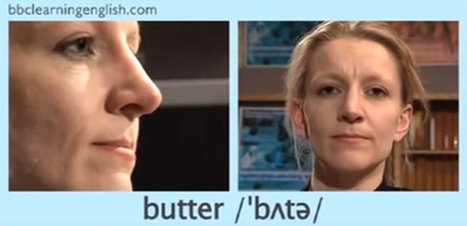

Now try reading these sentences aloud :

1) How many brothers and sisters have you got?
2) How often do you play tennis?
3) What kind of music do you like?
4) What time do you usually get up?
5) How much does it cost?

Now listen to me reading them : What do you hear / notice?

I will read each sentence, after which you will copy/ imitate me.

Try again : The bold letters are ‘schwa’ :

1) How many brothers and sisters have you got?
2) How often do you play tennis?
3) What kind of music do you like?
4) What time do you usually get up?
5) How much does it cost?

Notice that the schwa sound only occurs in unstressed words/ syllables.

Can you tell me the difference between content and function words ?
Listen for the /uh/ sound in these words:
See how the underlined vowel doesn’t say one of its normal sounds? Instead, it says a muffled /uh/ sound. Also, notice how the schwa appears in an unaccented syllable? That schwa is what makes these words trickier to read and spell.

