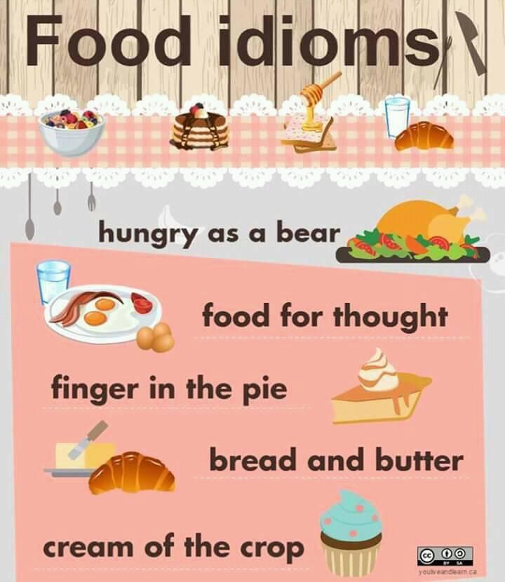

To be as hungry as a bear and/or horse : To be extremely hungry ! In need of food.

Example: I am as hungry as a bear ! I think we should have a big meal before we go shopping!

Food for thought: Something that should be thought about very carefully / new information that is important.

Example: Thank you for your your advice on relationships ! It has given me food for thought. / Your information about English grammar has given me food for though, I will start reading everyday !

Finger in the pie/ To have a finger in the pie : To be involved in or have an influence over many activities in a way that people do not always approve of.

Example: Our manager always assigns tasks and thinks we are incapable – she always wants a finger in the pie; even though we do not need it !

Bread and butter : Something, such as a job – that provides you with money/ financial stability.

Example: I am a creative person, so do a lot of art, however – being an English teacher is my bread and butter. ( How money is earned.)

Cream of the crop: The best person in a group. Borrowed from the French 'la crème de la crème,'

Urban dictionary : '' Being the cream of the crop is being the best of something, it ranges from sports to school to just being an awesome person.''.

Example:

